**V—3.28(Creating Docker Images):**

Docker file have a lines of configuration places inside of it. This configuration define how our container behaves.

Once we create a docker file. We pass it on to the docker client(docker cli) and docker cli provide the file to the docker server. Docker server goes through all the configurations and then build a useable image that can be used to startup a new container.

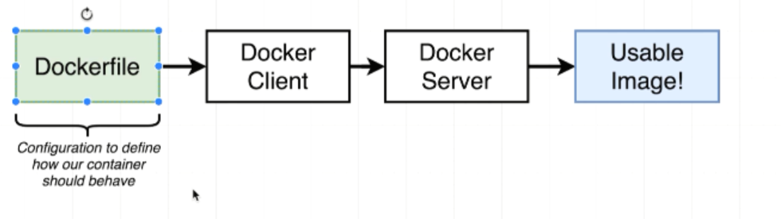

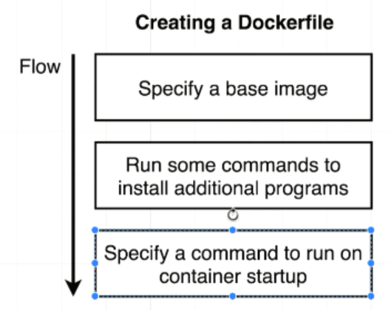

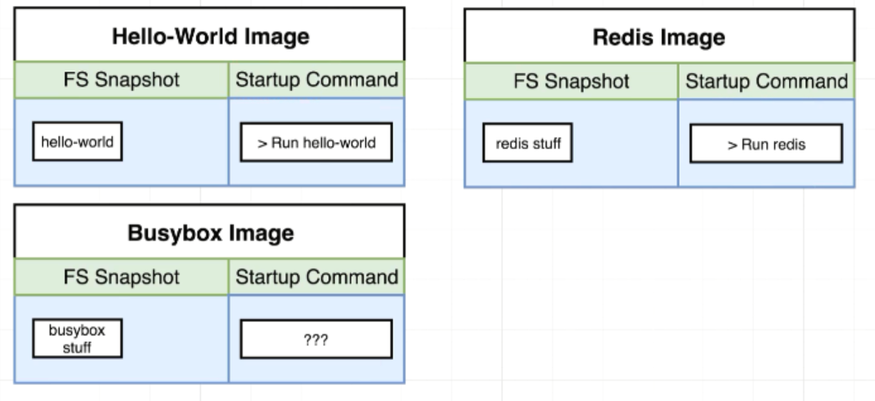

**V—3.30(Building a Docker file):**

**Make a Docker file that creates an image that going to run reddis server whenever it starts up**

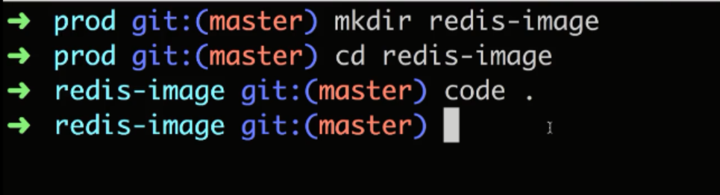

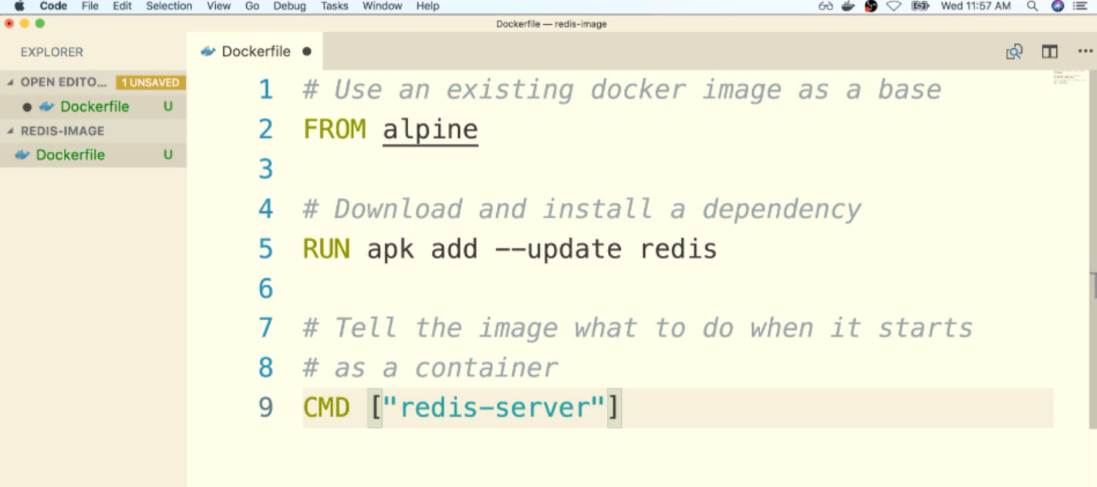

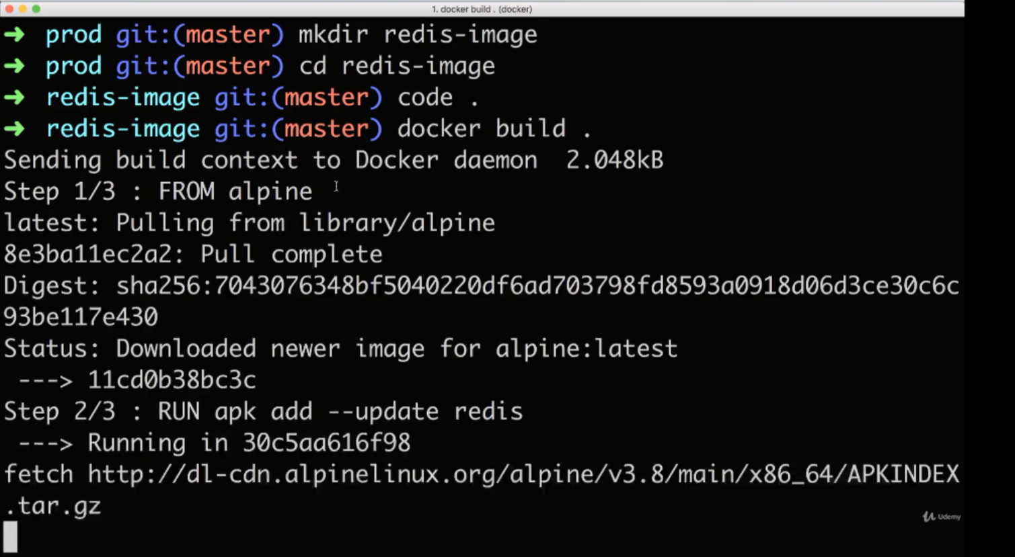

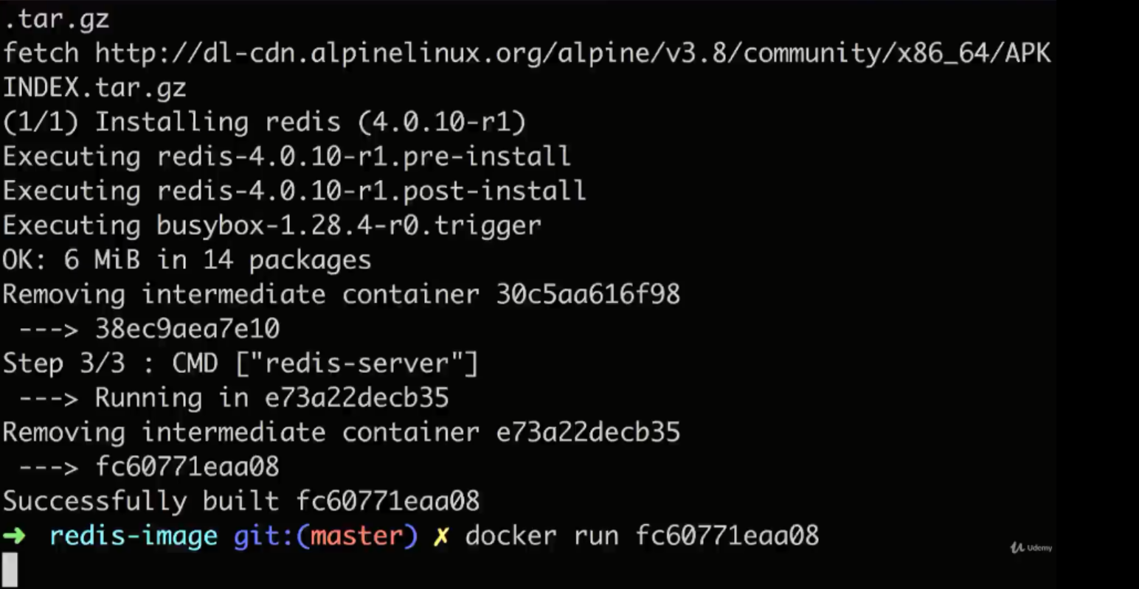

**V—3.31(Docker file Teardown):**

**Run instruction is used to run a command while we are preparing our custom image**

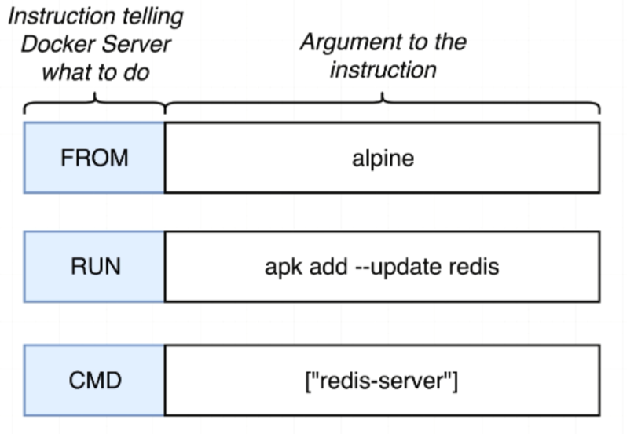

**V—3.32(What is a Base Image):**

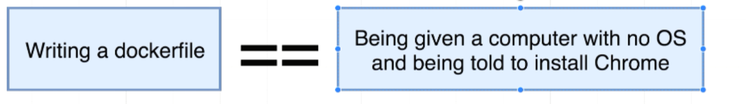

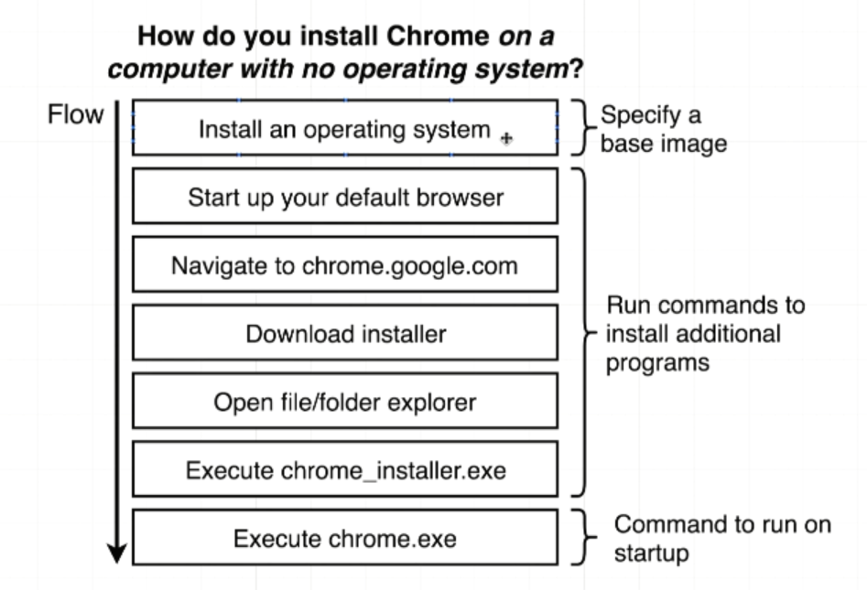

The purpose of specifying a base image is to kind of giving us an initial starting point or initial set of programs we can use further to customize our image.

We want to use the Alpine docker image as kind of initial operating system or starting point for the image that we are creating.

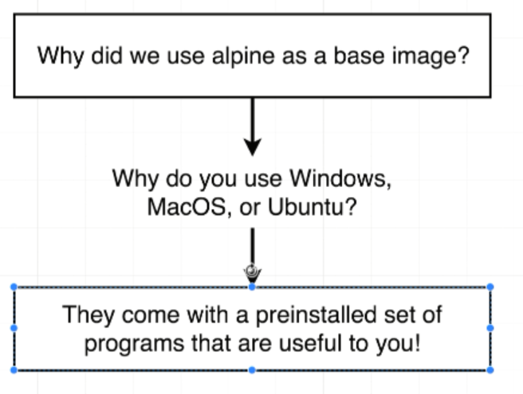

apk (Apache Package) that comes pre-installed on the Alpine.

**V—3.33(The Build Process in Details):**

**Why do we use docker build .?**

**What happens?**

When we run docker build . we are giving our docker file to the docker cli. Build command is all about taking docker file and generating an image out of it.

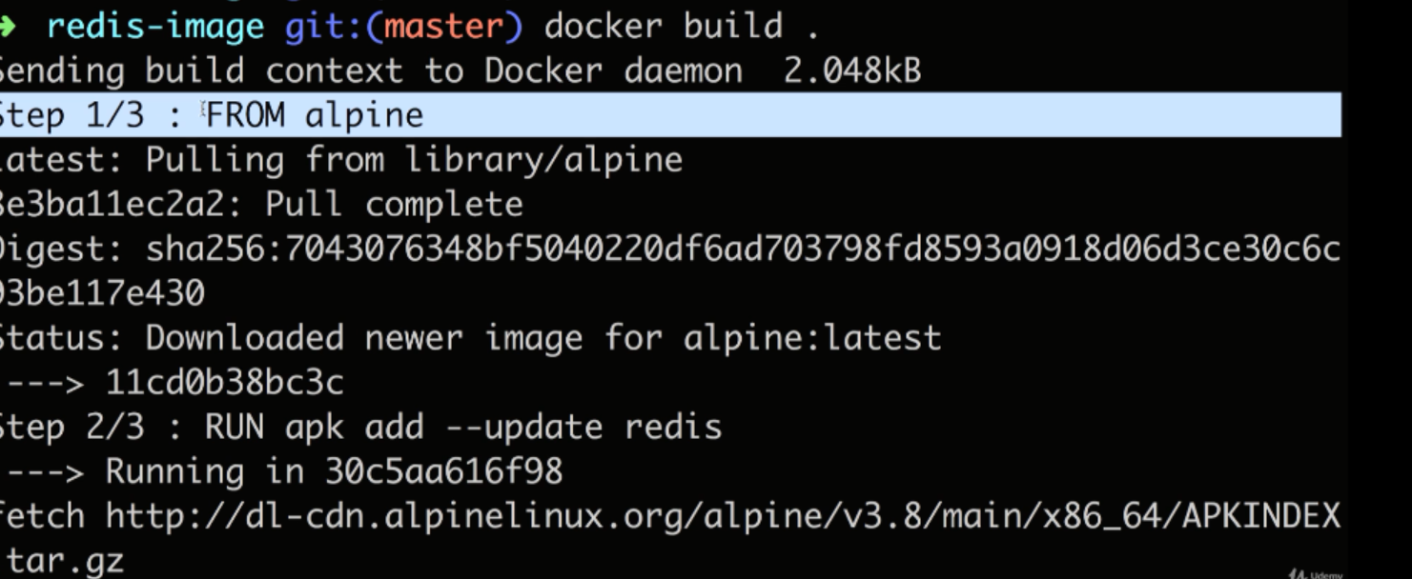

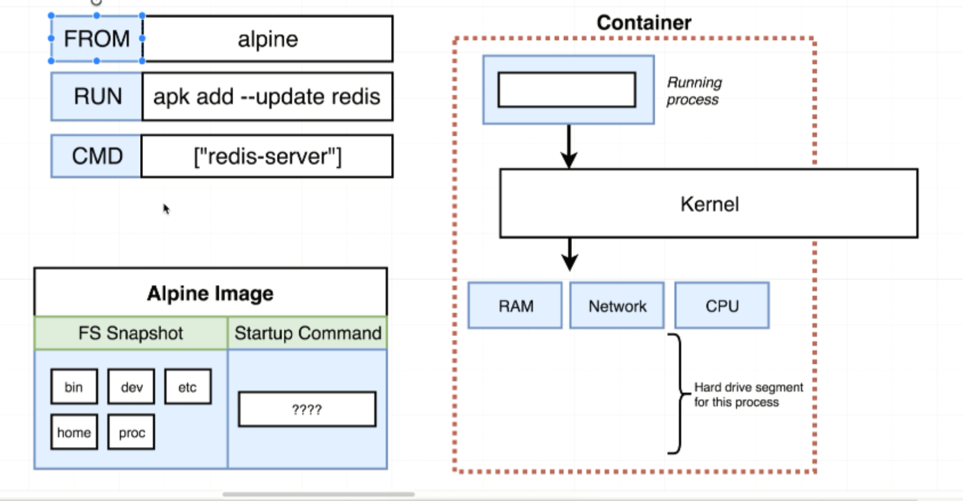

In step 2: It creates a temporary container by taking out the image that was sourced in previous step.

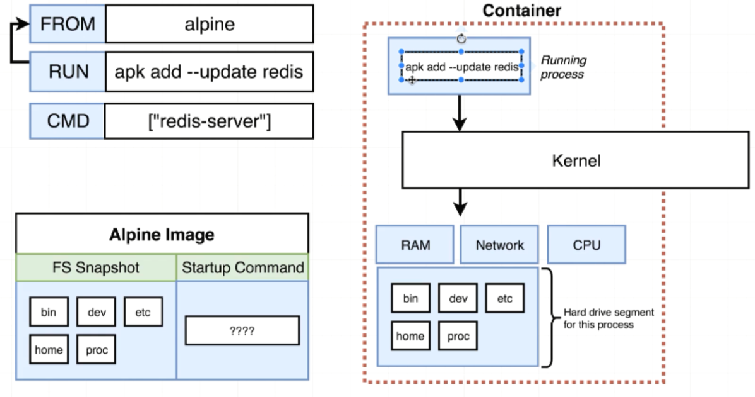

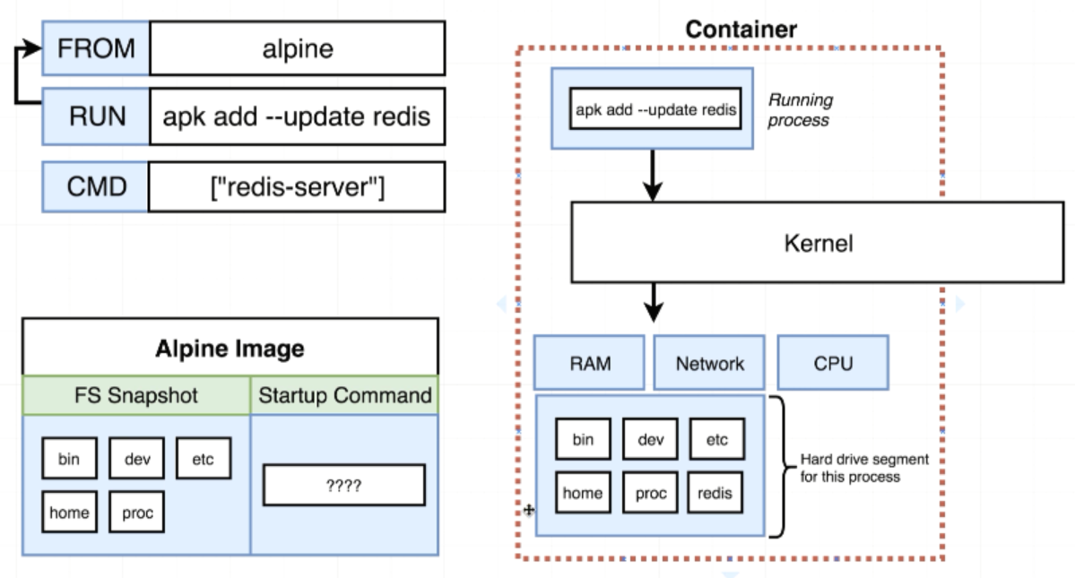

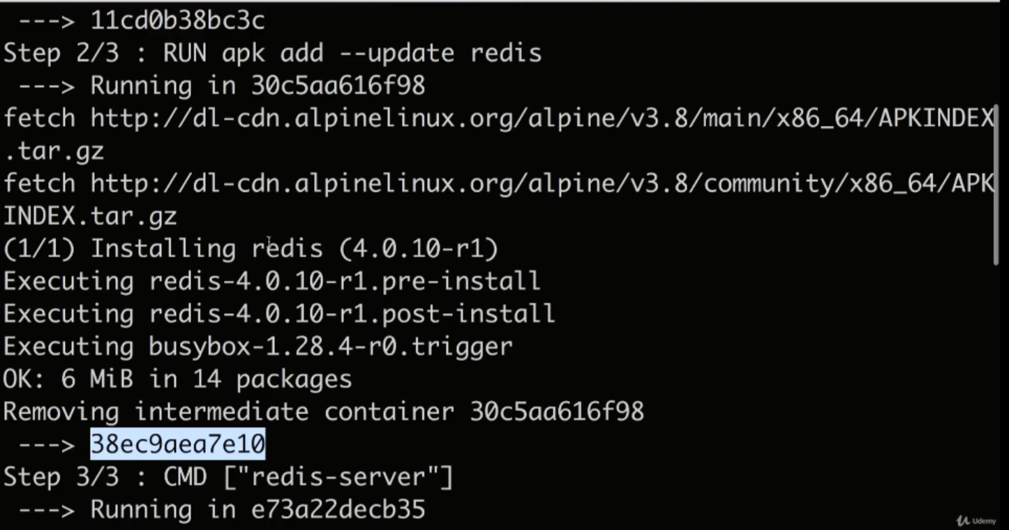

Before going to step 3/ after the reddis package has installed we took a filesystem snapshot of the container and then we stopped it entirely.

Take a file system snapshot and then we saved it as a temporary image.

Now we throw away that intermediate container.

Then Image looks like this:

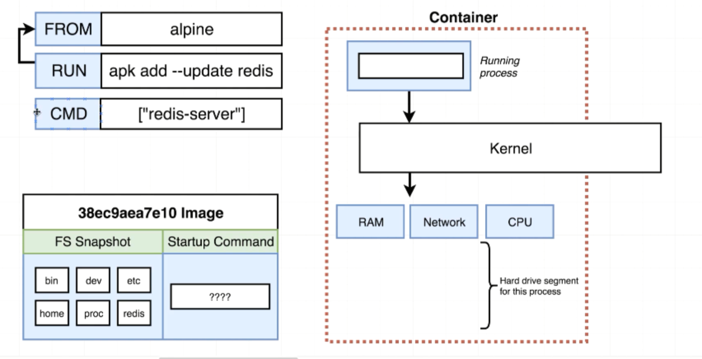

We created a temporary container out of the Alpine image and then we executed the run instruction inside that container. Then we took that containers file system and saved it as a temporary image

In step 3: It looks back to the previous step for the image that was created. We take the image filesystem snapshot and stuck it into the container hard drive.

CMD is setting up the primary process/command of the container.

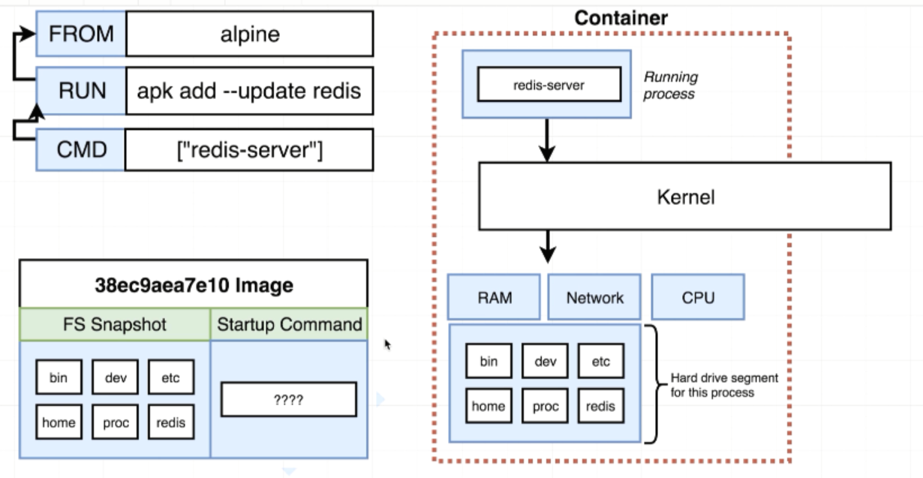

By taking the snapshot of the file system. It shutdowns the container by taking snapshot of the filesystem and saved it as an image

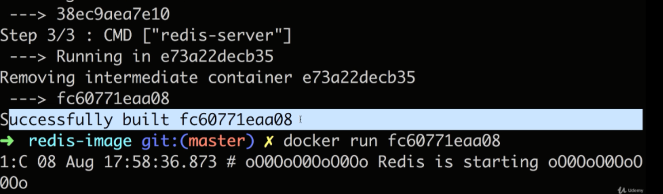

***End Result:***

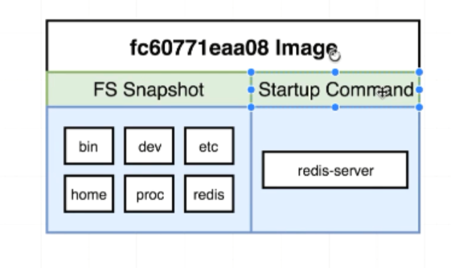

For every step in the docker file, we essentially take the image that was generated during the previous step. We created a new container out of it. We execute the command in the container or make change in it’s file system. We then look at that container and then take a snapshot of filesystem and then save it as an image or output(input for me) for the next instruction along the chain. When there is no more instructions to execute, the image that was generated by the last step is the output from the entire process as the final image.

**V—3.34(A Brief Recap):**

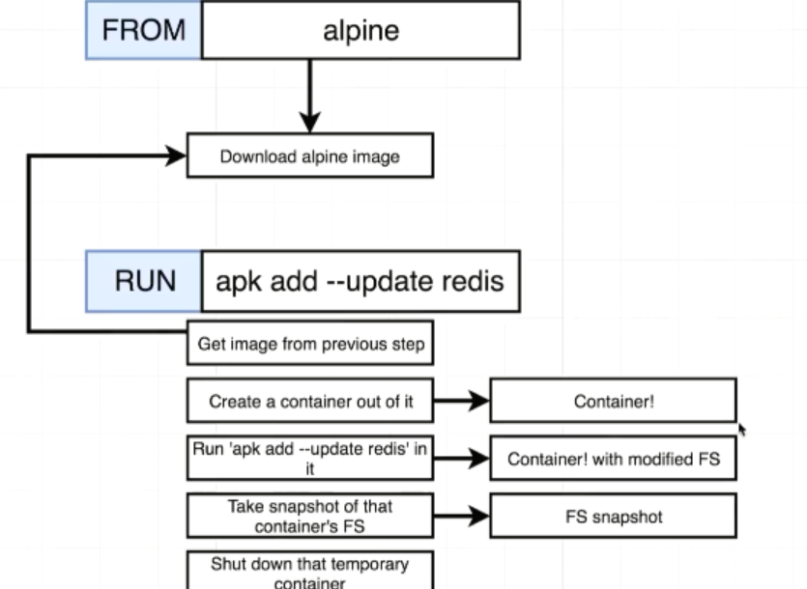

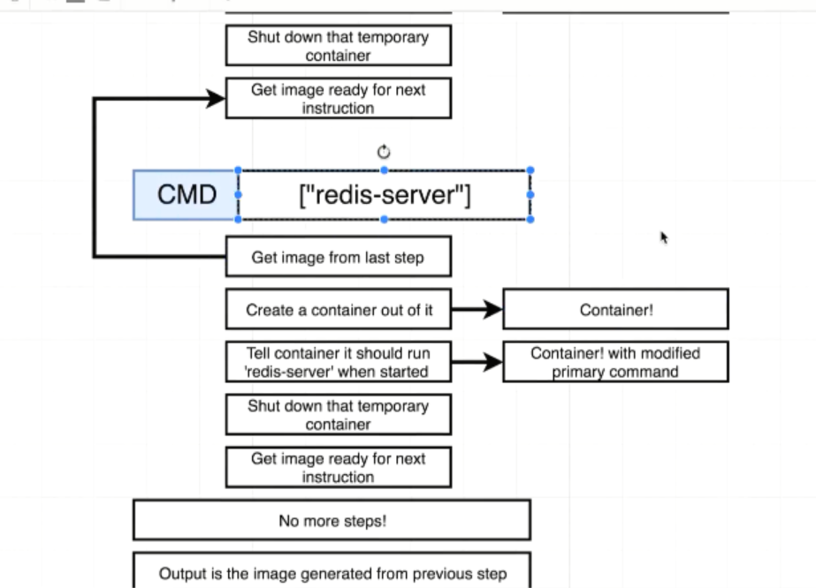

**V—3.35(Rebuilds with cache):**

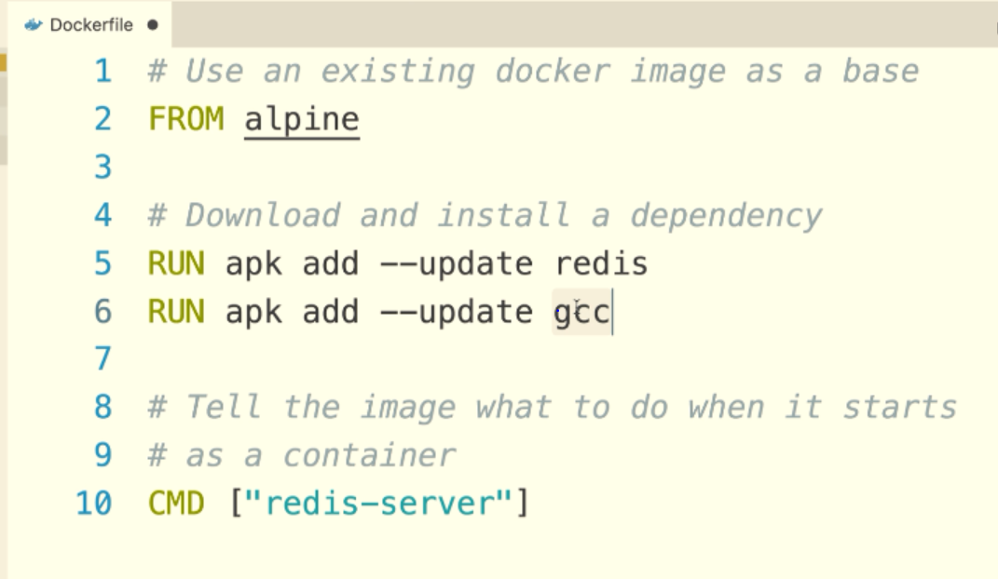

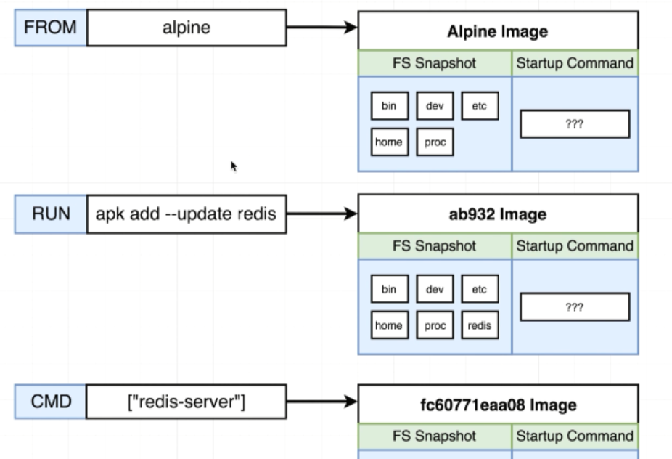

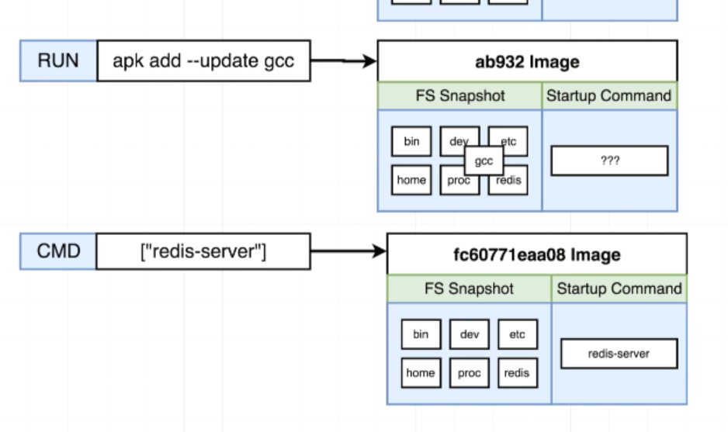

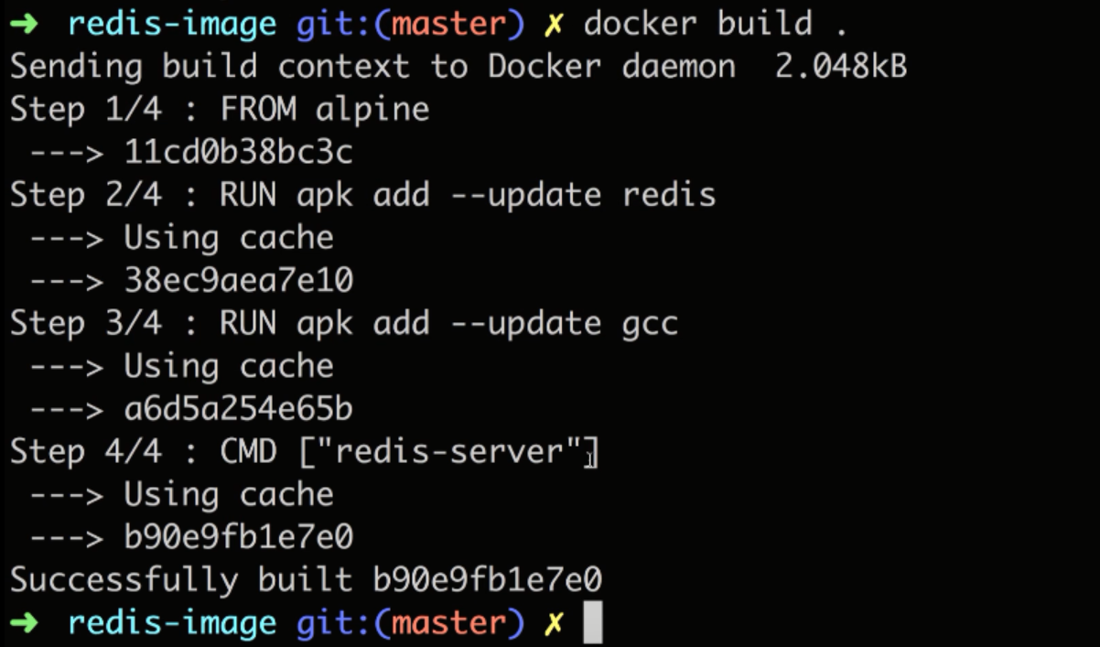If you run docker build .(second time) it takes everything from cache.

Adding cache version of redis to alpine and cached version of gcc to reddis instruction generated image

If sequence of instructions changed, the cache will also be different

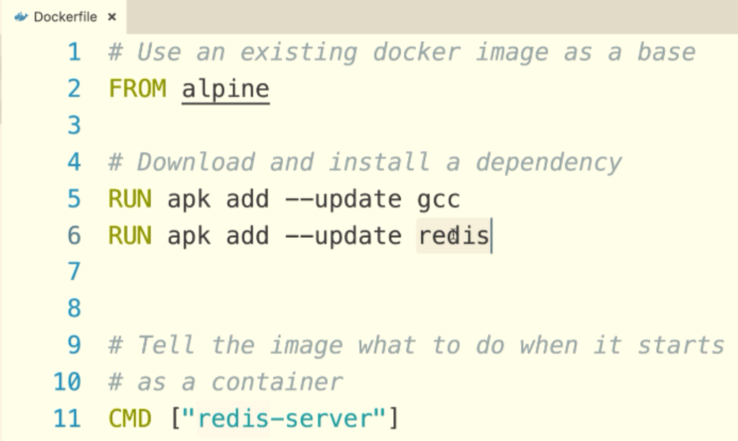

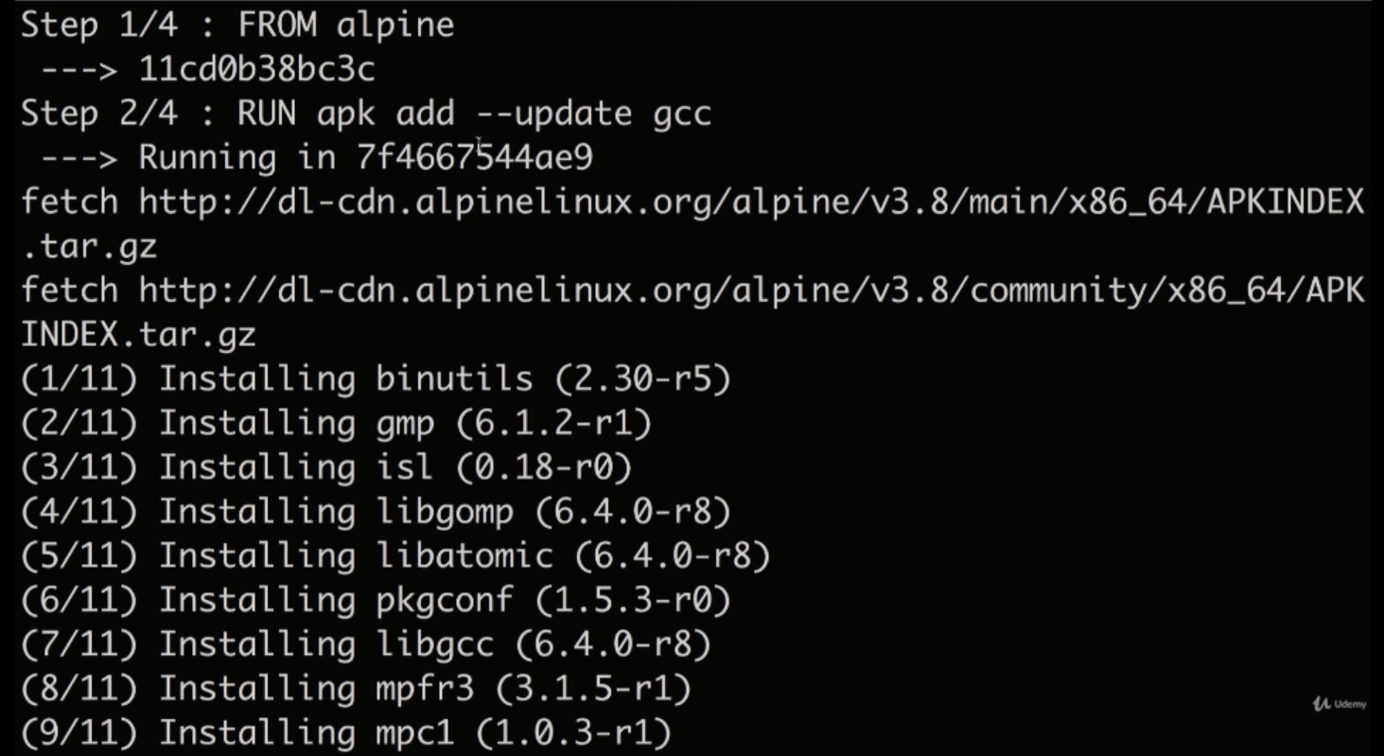

V—3.36(Tagging an Image):

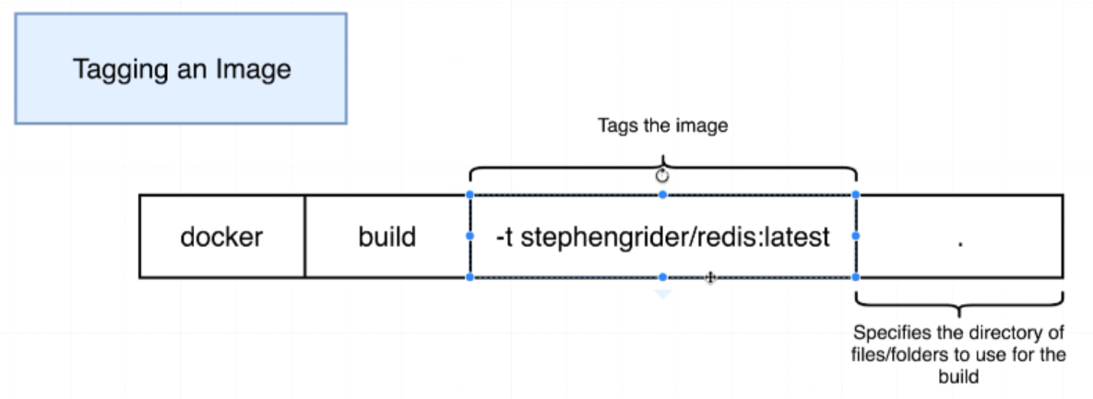

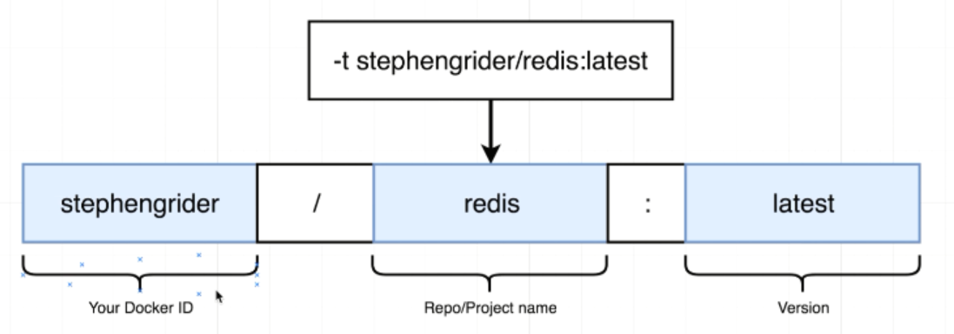

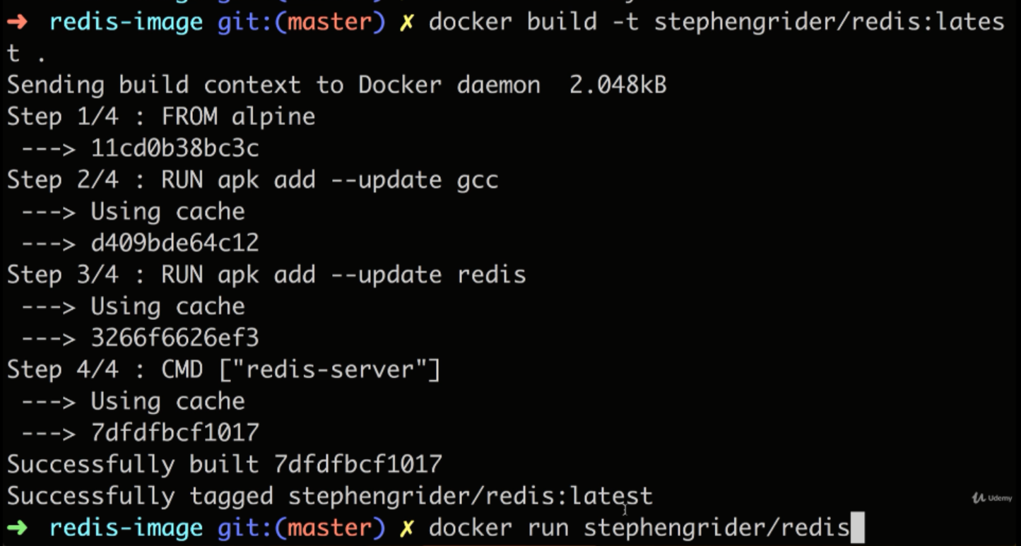

V—3.38(Manual Image Generation with Docker Commit):

